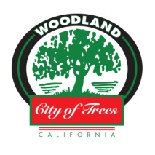
Homeless Sub-Committee Agenda
Wednesday, February 6, 2019
City Hall, 300 1st Street
City Manager’s Conference Room
4:00 – 5:30pm

City Council Subcommittee Members: Angel Barajas, Rich Lansburgh

- Approval of Agenda

- Public Comment

- Discussion Topics / Informational Updates
  - HOST Update
  - Preliminary Results from Homeless Count
  - Old County Jail Temporary Shelter Project (Fourth and Court St)
  - No Place Like Home Grant Application
    - Permanent Supportive Housing
    - 4th and Hope / Friends of the Mission
  - “County Plan to Address Homelessness”
  - Tiny Homes Concept (partnership with Yolo County and Housing Authority)

- Adjournment

Next Meeting Date: TBD

