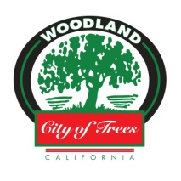
Homeless Sub-Committee Agenda
Tuesday, May 7, 2019
City Hall, 300 1st Street
City Manager’s Conference Room
4:30 – 6:00pm

City Council Subcommittee Members: Angel Barajas, Rich Lansburgh

Purpose – provide status update on elements of our comprehensive Homeless Action Plan
- Point-In-Time Homeless Count

- Managing Issues related to Homelessness – HOST UPDATE
  - Homeless camps
  - Referral to services (incl. MDT)
  - Coordination across law enforcement agencies
  - Shopping cart program

- Shelter Update
  - Emergency Shelter (Old County Jail) project
  - City of Woodland Emergency Winter Shelter wrap-up
  - Fourth & Hope Update

- Housing Update
  - No Place Like Home Grant – status update / timeline
  - Tiny Homes Project Concept (5th @ Oak) – Yolo County / Yolo Housing Authority
  - Woodland Opportunity Village Update (Kentucky @ Freeman)
  - YCCC Project proposal (???)

- Homeless Governance Model for Yolo County
  - Yolo County Plan to Address Homelessness (NPLH) Jan 2019
  - 10-year Plan Commission (abolish/sunset)
  - Potential countywide JPA

Next Meeting Date: TBD

