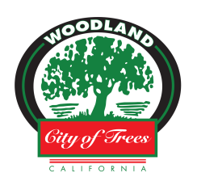
Community Development Department
300 First Street, Woodland CA 95695
(530) 661-5820

The following companies receive Electronic (Watermarked) Copies of all City of Woodland Projects out to bid:

Construction Bidboard, Inc  Website: www.ebidboard.com  (619) 688-0585  Email: planroom@ebidboard.com | Dodge Data & Analytics  Website: www.construction.com  (800) 393-6343  Email: support@construction.com
Placer County Contractors Association and Builders Exchange  Website: www.pccamembers.com  (916) 771-7229  Email: planroom@placerbx.com | Peninsula Builders Exchange  Website: www.constructionassistant.com  (650) 591-4486  Email: support@constructionplans.com
Shasta Builders Exchanges  Website: www.shastabe.com  (530) 221-5565  Email: planroom@shastabe.com | Sacramento Regional Builders Exchange  Website: www.srbx.org  (916) 442-8991  Email: planroom@srbx.org
Marin Builders Association  Website: www.marinba.org  (415) 462-1220  Email: mba@marinbuilders.org | BidAmerica  Website: www.bidamerica.com  (951) 290-3648  Email: planroom@bidamerica.com
Valley Contractors Exchange  Website: www.vceonline.com  (530) 343-1981  Email: elizabeth@vceonline.com | Construction Data Company  Website: www.cdcnews.com  (512) 634-5981  Email: plans@cdcnews.com
Bay Area Builders Exchange
Website: www.beac.com
(510) 483-8880
Email: planroom@bayareabx.com

